Case Study 75: Integrated Student Record Consistency Checker
1. Problem Statement
Validate student identifiers, names, marks, attendance and course records stored using lists and tuples. Detect duplicates, missing values and inconsistent academic records.
2. Objectives
Detect duplicate roll numbers.
Validate required student fields and mark ranges.
Check attendance range and course registration.
Display valid and invalid records with reasons.
3. Assumptions
A valid roll number is unique and begins with IT.
Name cannot be empty.
Marks must be between 0 and 100 and attendance between 0 and 100.
At least one course must be registered.
4. Algorithm
Create student records as tuples.
Maintain a list of previously seen roll numbers.
Check each field and add validation errors.
Mark records with no errors as valid.
Display errors for invalid records.
5. Flowchart
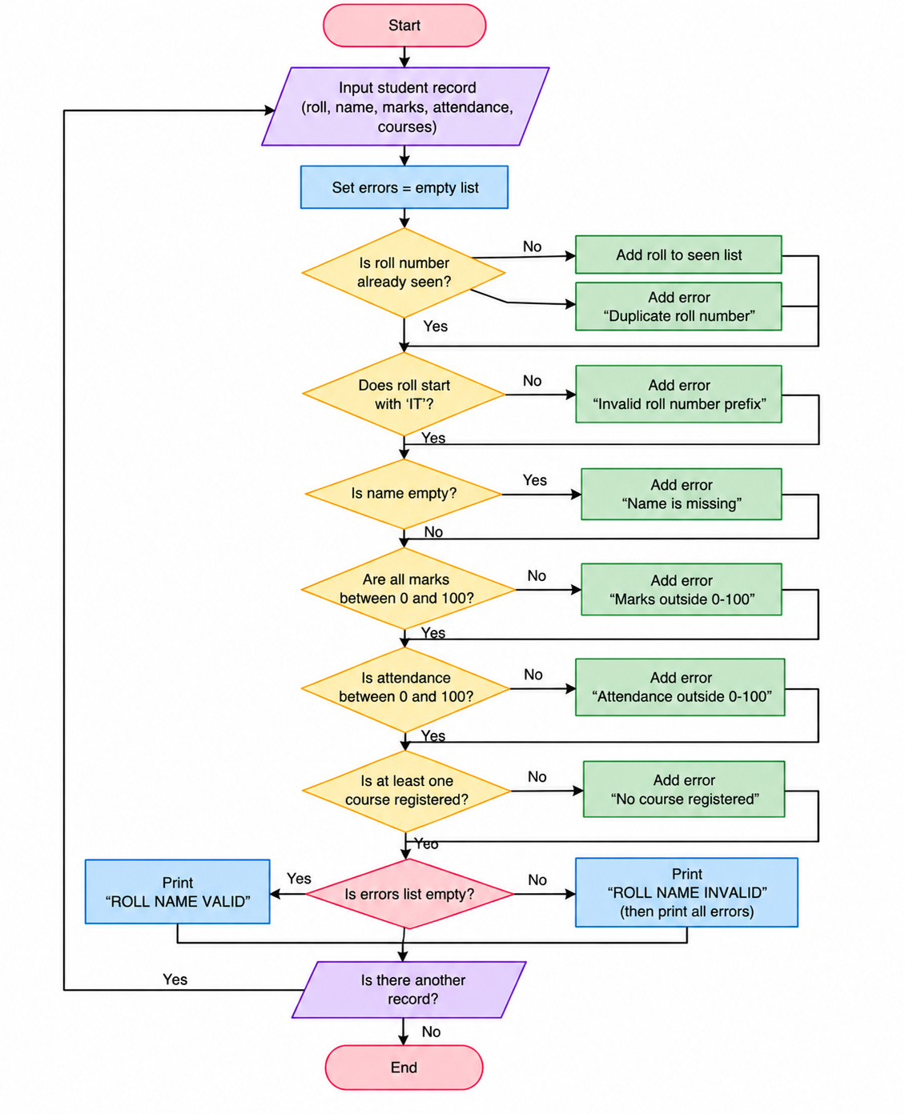
6. Pseudocode
START
Create student records as tuples.
Maintain a list of previously seen roll numbers.
Check each field and add validation errors.
Mark records with no errors as valid.
Display errors for invalid records.
Display result
STOP
7. Test Cases
Input / Record | Expected Result
IT101 first record | Valid
IT101 second record | Duplicate roll number
IT104 | Missing name, invalid marks, invalid attendance and no course
8. Output Screenshot
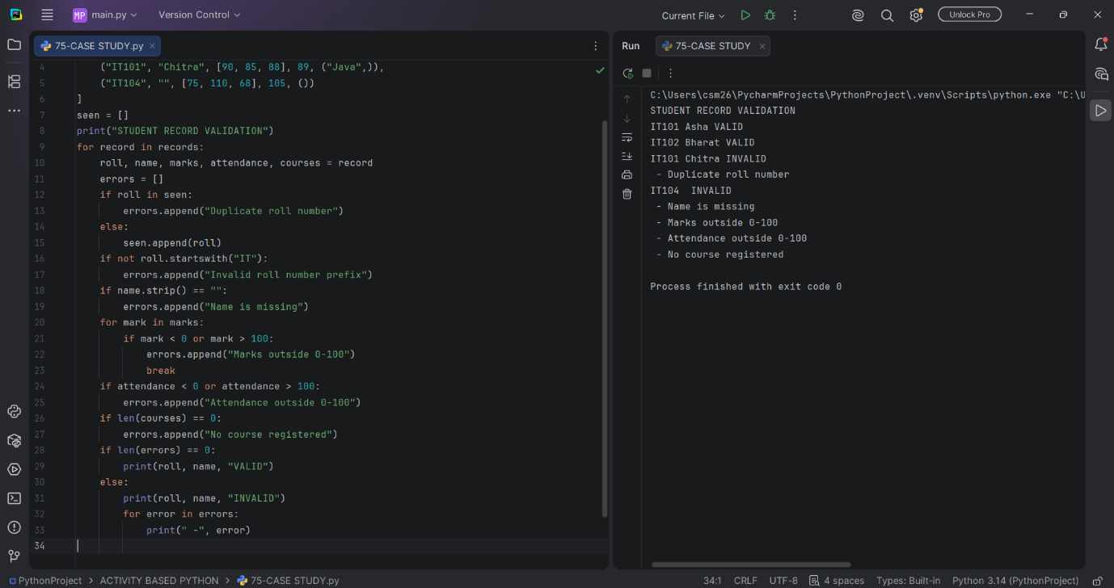
9. Conclusion
The program checks student data consistency using tuples, lists, loops and conditional statements.

